19.9
10.2
13.6
2.6
Treasure
Hunt
Treasure
Hunt
Treasure
Hunt
Treasure
Hunt
Treasure
Hunt
Treasure
Hunt
Treasure
Hunt
Treasure
Hunt

Find the length of the arc (1 d.p.)
Find the length of the arc (1 d.p.)
Find the area of the sector (1 d.p.)
Find the length of the arc (1 d.p.)
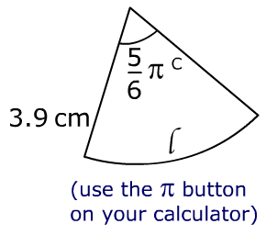
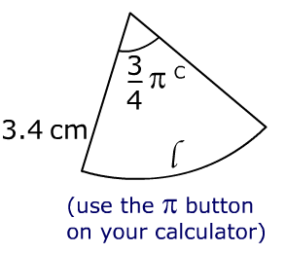
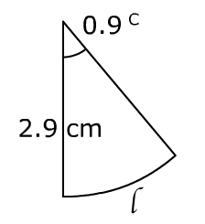
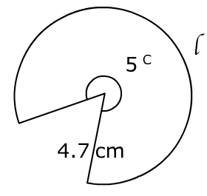

55.2
23.5
8.0
3.8

Find the area of the sector (1 d.p.)
Find the area of the sector (1 d.p.)
Find the area of the sector (1 d.p.)
Find the length of the arc (1 d.p.)

Treasure
Hunt
Treasure
Hunt
Treasure
Hunt
Treasure
Hunt

