Common mistakes in integration

Find the mistakes explain what the problem is and offer advice about how to sort out the problem.

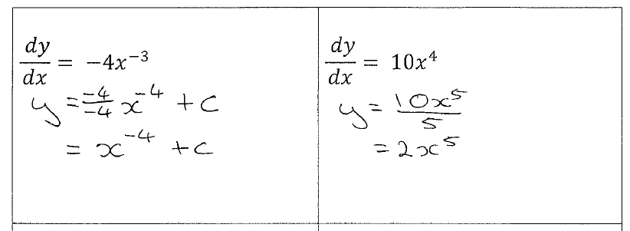
Comments: Comments:

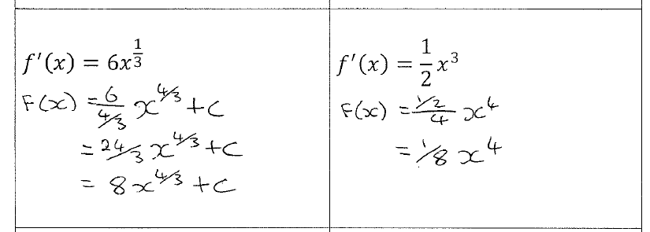

Comments: Comments:

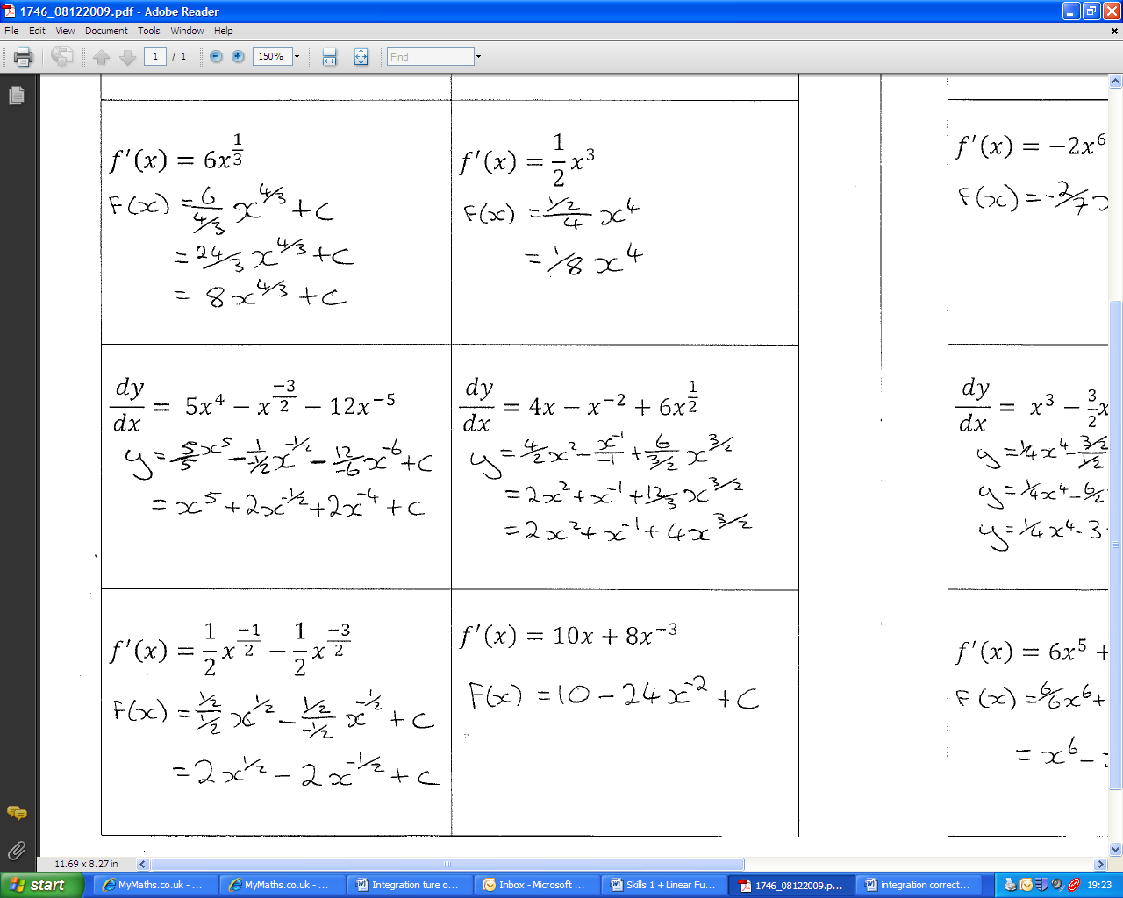
Comments: Comments:

Comments: Comments:

These mistakes are easy to make. What do you think are the most important things to check when integrating?

