Having fun with graphs in Autograph!

Familiarity and confidence with graph sketching and transformations is lacking in many A level students we see, perhaps stemming from the fact that they may never have been asked before to simply sketch a graph as opposed to accurately plotting one. This leads to a lack of confidence in obvious areas such as when working explicitly with graph transformations in the Core modules, but also creates additional problems with coordinate geometry work in general across Core and FP modules and other topics such as functions work in C3, if students lack the confidence to draw a diagram.

Autograph can be used in lots of ways to help - one task that has been successful at a number of levels (can also be a KS4 task) is to use fun shaped graphs which can be printed out and ask students to identify what the transformations are if a particular one is designated as f(x). (Which one this is could also be changed around..) The transformations used can be varied as appropriate for the level of work required, and can also include modulus functions and so on. They seem to be much more interested in doing this if the original graph is an unusual shape!
This task usually uncovers a few misconceptions and prompts some good discussion across the class.
Answers can easily be checked by having students actually put them in to Autograph – the task itself can be done with or without computer access for the students as they go along, depending on whether you want them to be able to get instant feedback on their answers.

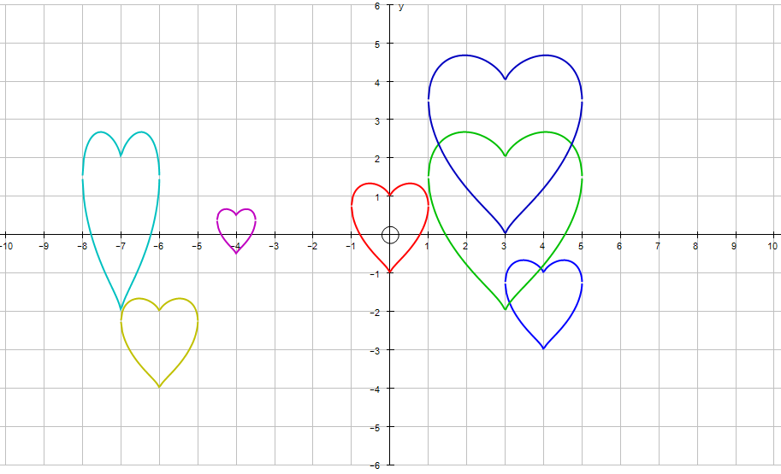

A similar idea that allows students to build confidence and familiarity with any new kind of graph or transformation (or combination of these) is to set a task that involves writing something (e.g. their name) in the software. Requirements can be defined according to the group and the focus you want – e.g. you must include at least 3 parabolas and 3 circles, or you might require a certain number of cubics, modulus functions, ellipses, hyperbolas,... You could also require equations to be entered in cartesian form, parametric form, polar form, vector form (for straight lines anyway) or any combination of these.
Achieving something like this in Autograph will also require students to restrict the domain appropriately so that they only have the section of the graph plotted that they actually want to appear. This is useful for C3 functions work, but can be explained to lower groups and for them, provides a useful additional requirement to consider what x value will need to be entered to stop the graph at the point which is not actually on the x axis.
The examples here were actually done by a KS4 class (who are covering Additional Maths FSMQ in parallel to their GCSE) as these were the files I managed to find copies of, but it’s obviously very flexible and can be used at a lot of levels (including lower levels too if you are only working with straight lines).

