M1 - Kinematics of a Particle moving in a Straight Line Questions

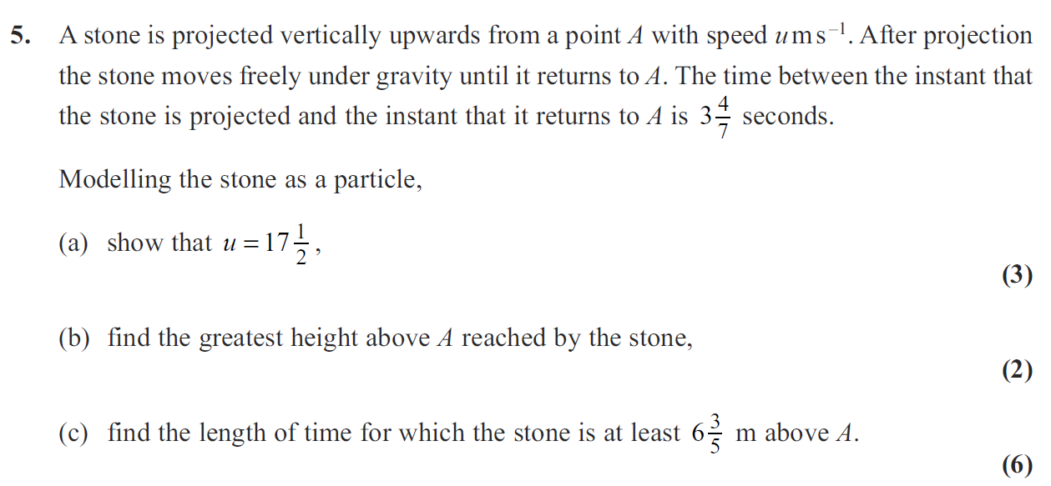
January 2012

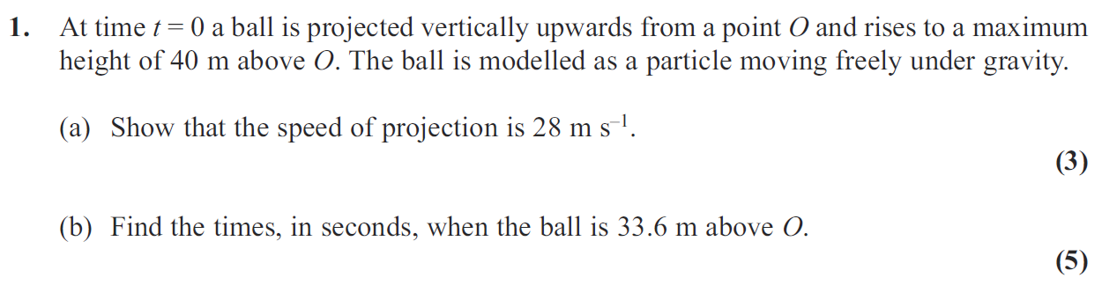
May 2011

Jan 2011

2. A ball is thrown vertically upwards with speed u m s⁻¹ from a point P at height h metres above the ground. The ball hits the ground 0.75 s later. The speed of the ball immediately before it hits the ground is 6.45 m s⁻¹ . The ball is modelled as a particle.

(a) Show that u = 0.9.
(3)
(b) Find the height above P to which the ball rises before it starts to fall towards the ground again.
(2)
(c) Find the value of h.
(3)

May 2010

5. Two cars P and Q are moving in the same direction along the same straight horizontal road. Car P is moving with constant speed 25 m s⁻¹. At time t = 0, P overtakes Q which is moving with constant speed 20 m s⁻¹. From t = T seconds, P decelerates uniformly, coming to rest at a point X which is 800 m from the point where P overtook Q. From t = 25 s, Q decelerates uniformly, coming to rest at the same point X at the same instant as P.

(a) Sketch, on the same axes, the speed-time graphs of the two cars for the period from t = 0 to the time when they both come to rest at the point X.
(4)
(b) Find the value of T.
(8)

May 2010

6. A ball is projected vertically upwards with a speed of 14.7 m s⁻¹ from a point which is 49 m above horizontal ground. Modelling the ball as a particle moving freely under gravity, find

(a) the greatest height, above the ground, reached by the ball,
(4)
(b) the speed with which the ball first strikes the ground,
(3)
(c) the total time from when the ball is projected to when it first strikes the ground.
(3)

Jan 2010

2. An athlete runs along a straight road. She starts from rest and moves with constant acceleration for 5 seconds, reaching a speed of 8 m s^{–1}. This speed is then maintained for T seconds. She then decelerates at a constant rate until she stops. She has run a total of 500 m in 75 s.

(a) Sketch a speed-time graph to illustrate the motion of the athlete.
(3)
(b) Calculate the value of T.
(5)

